FORGET ME NOT

System Requirements Specification

____________________________________________________________________________

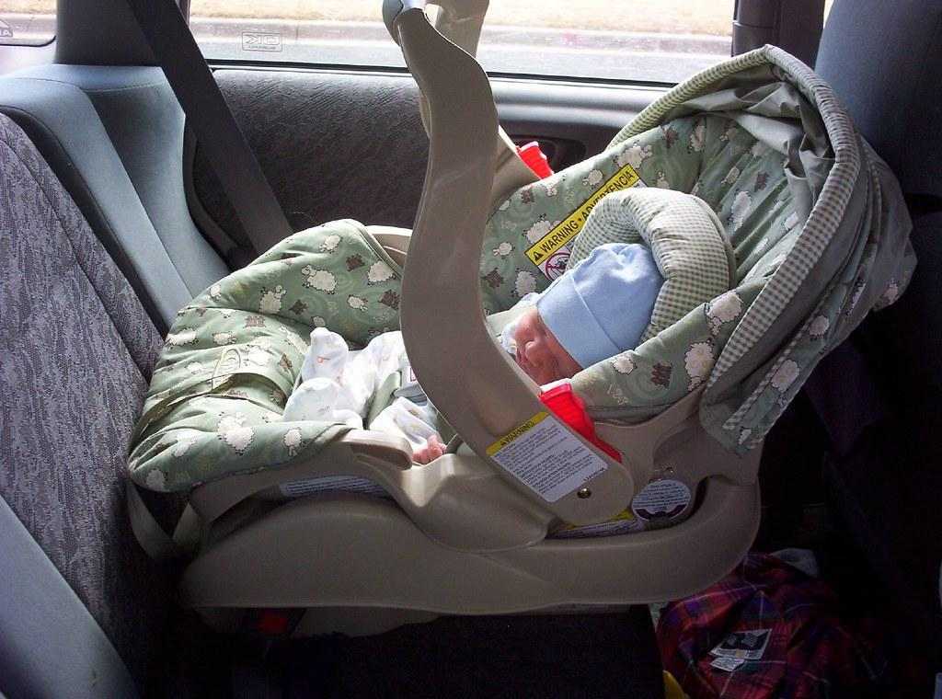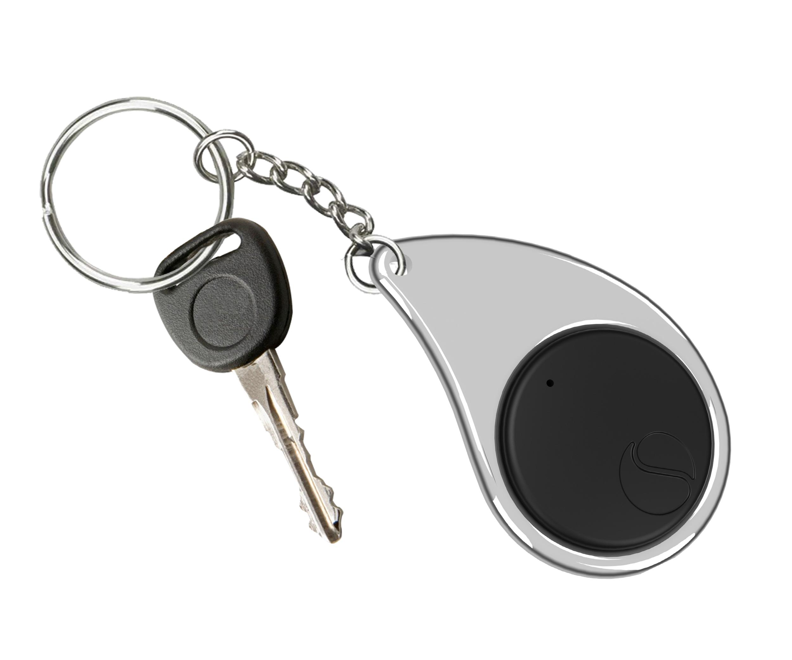

Revision 2

October 6th, 2019

ECE 497 Capstone Project Group 1

Sponsor: Laura Ochsner

[lauraochsner@hotmail.com](mailto:lauraochsner@hotmail.com)

Group Members: Jacob Cassady

Mason Gardone

Raley Suter

**Table of Contents**

**System Purpose** **3**

**Background Information** **3**

**System Operational Concept** **3**

**System Diagram and Description** **3**

System Requirements 5

Environmental 5

Manufacturability 5

Sustainability 5

Health/Safety 6

Major Components 7

Hardware Components 7

Power Source 7

GPS Module 7

Microcontroller 8

Buzzer 8

Push Buttons 9

LEDs 9

Antenna 9

RF Telemetry Module 10

Software Components 10

Communication Parser 10

Model 11

Power Estimator 12

Distance Calculator 12

**External Interfaces** **13**

Push Buttons 13

GPS Communication 13

Antenna 13

LEDs 13

Power LED 14

Sync LED 14

Power Source 14

**Internal Interfaces** **14**

Digital Outputs 14

Digital Inputs 14

Antenna to GPS and RF ICs 14

Power Source 15

**Design Constraints** **15**

**List of References/Standards** **15**

**Appendices** **15**

LIST OF FIGURES

**Fig.1 Forget-Me-Not System Diagram 4**

# 

# **System Purpose**

According to the National Safety Council, an average of 38 child deaths occur every year due to children being left in hot cars. While not a staggering statistic, it is still a tragic one that can be almost entirely eliminated with a simple device. The purpose of the Forget Me Not device is to help remind parents that they have their child in the car with them, no matter the circumstance.

# **Background Information**

This system is a continuation of a computer engineering capstone project. The past capstone group was able to make a working prototype, but some features were not completed. The prototype had two working parts that could communicate with each other using radio frequency (RF). However, the system lacked a way to measure the distance between the two modules. A feature needed to make the system more robust. The alarm was also too quiet to be effectively heard in noisy environments; the volume must be increased and a vibration component must be added. The prototype was also too large to be useful. In order to use as a key fob, the system size must be greatly reduced. The current capstone project is focused on improving and adding these features.

# **System Operational Concept**

The system is meant to be used by parents and family members of small children. This device could also be used for other purposes not explained here. The system is made of two components: a key fob and a module attached to a car seat. The two devices are synced to each other by pressing and holding a sync button, the light emitting diode (LED) will turn on when the sync is complete. Once the devices are synced and the fob moves 15 feet away from the car module, the fob will vibrate and sound a 80dB +/- 5dB alarm. The user can deactivate the alarm by pressing and holding a button on the key fob. The system also alerts the user to low battery with a blinking LED and a repeated sounding of the alarm.

# **System Diagram and Description**

The Forget Me Not System utilizes similar designs for its two major components, or subsystems: the Key Fob Subsystem and the Car Seat Subsystem. The Key Fob Subsystem will be kept with the operator, likely on their keychain. On the other hand, the Car Seat Subsystem will be kept with the child’s car seat.

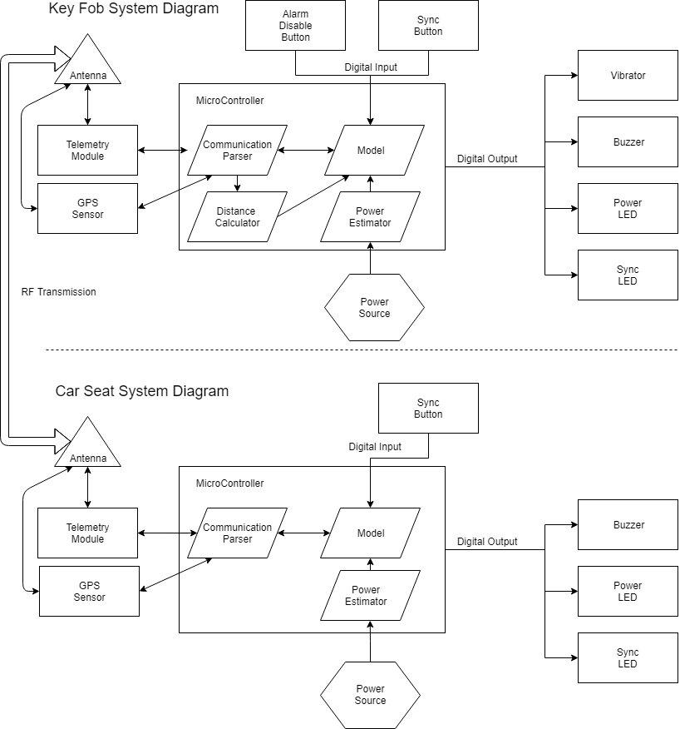

*Figure 1. Forget Me Not System Diagram.*

Global positioning system (GPS) sensors on each subsystem are used to calculate the subsystem’s location. This information is then broadcasted from the Car Seat Subsystem through the telemetry module. The Car Seat Subsystem’s GPS data is then received from the Key Fob Subsystem’s telemetry module through radio frequency (RF) communication. The distance between the two GPS points are then calculated to determine if the operator is inside or outside the alarm perimeter.

Additionally, the system must notify the operator of low power situations. To account for this, a software module will calculate the remaining power from the power source and feed this into the model. As *Figure 1* shows, both subsystems have digital output LEDs to display the occurrence of low power to the operator.

Lastly, buttons were added to the subsystems as digital inputs to give the operator some control over the system. A sync button on both Subsystems allows for the synchronization of subsystems with each other to ensure the alarm is monitoring the distance of the synced Key Fob Subsystem with respect to the distance of the Car Seat Subsystem. A “disable alarm” button was also added to the Key Fob Subsystem so the operator can confirm their child is with them.

## **System Requirements**

### **Environmental**

* + - 1. ***The system must be able to survive heat of 175 degrees.***

Since the ForgetMeNot system is likely to endure high heat situations when kept inside a car. To account for this, the system must be tested to operate when exposed to temperatures 175 degrees Fahrenheit and below.

* + - 1. ***The system must retain working power for 8 ± 1 days on a single full charge.***

The ForgetMeNot system needs to operate for several days of use. The benefit of the system is lost if the user is required to constantly change the batteries on each of the subsystems. Both subsystems must remain operating after 8 ± 1 days of intermittent use.

### **Manufacturability**

* + - 1. ***Key Fob Subsystem shall be no larger than 1.5”x3”x1”.***

It is important for the key fob subsystem be designed such that it can fit on a keychain. The subsystem must be designed to be no larger than 1.5” in width, 3” in length, and 1” in thickness.

### **Sustainability**

* + - 1. ***The system shall allow for the syncing of different combinations of the subsystems.***

The Forget Me Not system must allow for N-N connections between an N number of Key Fob Subsystems and an N number of Car Seat Subsystems with N equal to 3. This is because there might be multiple operators with different Key Fob Subsystems and one or more Car Seat Subsystems (children) or one operator with one or more Car Seat Subsystems. To accommodate this, the subsystems must be able to synchronize with subsystems of the opposite type.

### **Health/Safety**

* + - 1. ***The system shall be disarmed by pressing the disarm button on the Key Fob Subsystem.***

The system shall be disarmed whenever the disarm button is pressed. This disarm button shall work both inside and outside of a 15 foot perimeter from the vehicle as long as a sufficient communication connection is available to the key fob subsystem.

* + - 1. ***Key Fob Subsystem shall make audible sound and vibrations once the fob exits a 15 foot perimeter around the car module before the alarm is disarmed.***

The Key fob shall alarm the operator when they leave the perimeter before disarming the system. This alarming will be done through both sound and vibration.

* + - 1. ***The system’s alarm sound should reach 80dB ±5 dB.***

The system must create an alarm sound that is both audible and non-damaging to the operator. This value was chosen because 80 dB is where damage starts to occur to the operator’s hearing.

* + - 1. ***Alarm shall rearm automatically when user re-enters the perimeter of 15 feet from the Car Seat Subsystem.***

The alarm must rearm itself when the operator re-enters the alarm boundary. This is to ensure a sustainable system that works after disarming and reentering the boundary without additional configuration steps from the operator. This can be validated by disarming the system, leaving the boundary, re-entering the boundary, and then leaving the boundary again. If this requirement is met, the alarm will sound.

* + - 1. ***The system shall alert the operator via low power LED.***

Since this is a safety system, it is critical the operator is promptly alerted to power issues. To accommodate this need, the system must display through LED and an audible signal when the power is low.

* + - 1. ***The Key Fob Subsystem must operate with reduced functionality at low power.***

If the key fob system is reaching a point of low power, it must shut off its radio communication and other costly power systems and turn on a low-power LED to increase the likelihood that the operator is notified of the low power level.

## **Major Components**

### **Hardware Components**

#### **Power Source**

The power source provides electrical power to the system. Each subsystem has its own power source.

* + - * 1. ***Allocated Functional Requirements***
* 4.1.1.1 - System must be able to survive heat of 175 degrees.
* 4.1.1.2 - System must retain power for 7 days on a single charge.
  + - * 1. ***Derived Requirements***

Power Source must provide adequate current and voltage to all hardware components that require power.

#### **GPS Module**

The GPS sensor will be used to determine the distance between the two modules. Each module will have a GPS sensor and will use the same antenna as the RF telemetry module.

* + - * 1. ***Allocated Functional Requirements***
* 4.1.1.1 - System must be able to survive heat of 175 degrees.
* 4.1.1.2 - System must retain power for 7 days on a single charge.
* 4.1.4.2 - Key Fob Subsystem shall make audible sound and vibrations when the fob is outside of 15 feet from the car module before the alarm is disarmed.
* 4.1.4.4 - Alarm shall rearm automatically when user re-enters the perimeter of 15 feet from the Car Seat Subsystem.
  + - * 1. ***Derived Requirements***

The GPS Module must be accurate at determining position +/- 3 meters.

#### **Microcontroller**

The microcontroller will be the center of the module where the data from the GPS and RF will be processed and control the alarm and LEDs via I/O pins.

* + - * 1. ***Allocated Functional Requirements***
* 4.1.1.1 - System must be able to survive heat of 175 degrees.
* 4.1.1.2 - System must retain power for 7 days on a single charge.
* 4.1.3.1 - The system shall allow for the syncing of different combinations of the subsystems.
* 4.1.4.1 - The system shall be disarmed by clicking the “disarm” button on the Key Fob Subsystem.
* 4.1.4.2 - Key Fob Subsystem shall make audible sound and vibrations when the fob is outside of 15 feet from the car module before the alarm is disarmed.
* 4.1.4.4 - Alarm shall rearm automatically when user re-enters the perimeter of 15 feet from the Car Seat Subsystem.
  + - * 1. ***Derived Requirements***

The microcontroller requires three digital outputs for the buzzer and LEDs, two digital inputs for the buttons and sufficient Serial Peripheral Interface (SPI) or Universal Asynchronous Receiver/Transmitter (UART) communication channels for communication with the GPS sensor and telemetry module.

#### **Buzzer**

The buzzer will be used to make the 80 ± 5 dB alarm that the system requires. The buzzer will be controlled by the microcontroller.

* + - * 1. ***Allocated Functional Requirements***
* 4.1.1.1 - System must be able to survive heat of 175 degrees.
* 4.1.1.2 - System must retain power for 7 days on a single charge.
* 4.1.4.2 - Key Fob Subsystem shall make audible sound and vibrations when the fob is outside of 15 feet from the car module before the alarm is disarmed.
* 4.1.4.3 - The System’s alarm sound should reach 80dB ± 5dB.
  + - * 1. ***Derived Requirements***

The buzzer must be capable of producing acoustic intensities of 80dB +/- 5dB.

#### **Push Buttons**

Two push buttons will be on the fob module. One button will be used to delay the alarm system. The other button will be used to sync the fob to the car module. The car module will have one button for syncing and one button for disabling the alarm.

* + - * 1. ***Allocated Functional Requirements***
* 4.1.1.1 - System must be able to survive heat of 175 degrees.
* 4.1.1.2 - System must retain power for 7 days on a single charge.
* 4.1.3.1 - The system shall allow for the syncing of different combinations of the subsystems.
* 4.1.4.1 - The system shall be disarmed by clicking the “disarm” button on the Car Seat Subsystem.

#### **LEDs**

Two LEDs will be used on each subsystem. The LEDs are responsible for notifying the user of the model state. One LED will be used for power status. The other will be used in the syncing process.

* + - * 1. ***Allocated Functional Requirements***
* 4.1.1.1 - System must be able to survive heat of 175 degrees.
* 4.1.1.2 - System must retain power for 7 days on a single charge.

#### **Antenna**

The antenna will be used by both the GPS and the telemetry module. This flexible antenna will be mounted within the subsystems.

* + - * 1. ***Allocated Functional Requirements***
* 4.1.3.1 - The system shall allow for the syncing of different combinations of the subsystems.
* 4.1.4.2 - Key Fob Subsystem shall make audible sound and vibrations when the fob is outside of 15 feet from the car module before the alarm is disarmed.
* 4.1.4.4 - Alarm shall rearm automatically when user re-enters the perimeter of 15 feet from the Car Seat Subsystem.
  + - * 1. ***Derived Requirements***

The Antenna must be able to transmit signals within the frequency ranges of the GPS sensor and the telemetry module. GPS Signals are broadcasted on two frequency bands: 1575.42 MHz and 1227.6 MHz. Telemetry module frequency ranges vary.

#### **RF Telemetry Module**

Each subsystem will have its own telemetry module responsible for facilitating communication between subsystems. The telemetry modules will communicate through radio frequency waves.

* + - * 1. ***Allocated Functional Requirements***
* 4.1.1.1 - System must be able to survive heat of 175 degrees.
* 4.1.1.2 - System must retain power for 7 days on a single charge.
* 4.1.3.1 - The system shall allow for the syncing of different combinations of the subsystems.
* 4.1.4.1 - The system shall be disarmed by clicking the “disarm” button on the Car Seat Subsystem.
* 4.1.4.2 - Key Fob Subsystem shall make audible sound and vibrations when the fob is outside of 15 feet from the car module before the alarm is disarmed.
* 4.1.4.4 - Alarm shall rearm automatically when user re-enters the perimeter of 15 feet from the Car Seat Subsystem.
  + - * 1. ***Derived Requirements***

The telemetry module must reliably communicate between subsystems at a range of 25 feet.

### **Software Components**

#### **Communication Parser**

The communication parser is included in both subsystems. The software module designed for communication parsing is important for packing data into a telemetry packet as well as unpacking data stored in a telemetry packet. The communication parser module will facilitate the encoding/decoding of data passed through the telemetry module. Also, communication parser will be solely responsible for interfacing with the telemetry module.

* + - * 1. ***Allocated Functional Requirements***
* 4.1.3.1 - The system shall allow for the syncing of different combinations of the subsystems.
* 4.1.4.3 - The System’s alarm sound should reach 80 ± 5 dB.
* 4.1.4.1 - The system shall be disarmed by clicking the disarm button on the Car Seat Subsystem.
* 4.1.4.2 - Key Fob Subsystem shall make audible sound and vibrations when the fob is outside of 15 feet from the car module before the alarm is disarmed.
  + - * 1. ***Derived Requirements***

The Communication Parser must be able to encode and decode a message between the two systems without loss of any data.

The Communication Parser must account for partial reception of data packets including identifying packet start and end markers within the data stream.

#### **Model**

The model component is included in both subsystems. The model is a data structure with associated functions responsible for keeping track of the system’s dynamic state including the status of subsystems synced to the model. This component is important for the program to understand the moving parts. This component will be the central interface for all other software components.

* + - * 1. ***Allocated Functional Requirements***
* 4.1.3.1 - The system shall allow for the syncing of different combinations of the subsystems.
* 4.1.4.1 - The system shall be disarmed by clicking the disarm button on the Car Seat Subsystem.
* 4.1.4.2 - Key Fob Subsystem shall make audible sound and vibrations when the fob is outside of 15 feet from the car module before the alarm is disarmed.
* 4.1.4.4 - Alarm shall rearm automatically when user re-enters the perimeter of 15 feet from the Car Seat Subsystem.
* 4.1.4.5 - System shall alert the operator of low power.
* 4.1.4.6 - System must operate with reduced functionality at low power.
  + - * 1. ***Derived Requirements***

The model’s attributes must accurately describe the pertinent data regarding the subsystem’s program state as well as the program state of its synced subsystems at the point of last communication.

#### **Power Estimator**

The power estimator is included in both subsystems. The power estimator software module receives data from the power supply and uses it to estimate the amount of remaining power in the power supply.

* + - * 1. ***Allocated Functional Requirements***
* 4.1.1.2 - System must retain power for 7 days on a single charge.
* 4.1.4.5 - System shall alert the operator of low power.
* 4.1.4.6 - System must operate with reduced functionality at low power.
  + - * 1. ***Derived Requirements***

The power estimator must be able to accurately estimate the amount of power remaining.

The power estimator shall keep track of power dissipation rate and factor this into its estimate of remaining power.

The power estimator shall notify the model when to enter a reduced functionality mode to keep the “low power” LED on as long as possible.

#### **Distance Calculator**

The distance calculator is the only software component native to the Key Fob Subsystem without being included in the Car Seat Subsystem. This distance calculator takes two parameters, the GPS coordinates from each subsystem, and calculates the difference between them.

* + - * 1. ***Allocated Functional Requirements***
* 4.1.4.2 - Key Fob Subsystem shall make audible sound and vibrations when the fob is outside of 15 feet from the car module before the alarm is disarmed.
* 4.1.4.4 - Alarm shall rearm automatically when user re-enters the perimeter of 15 feet from the Car Seat Subsystem.
  + - * 1. ***Derived Requirements***

The distance calculator must calculate the distance between two GPS coordinates to the maximum precision of the input data.

# **External Interfaces**

### **Push Buttons**

* + - 1. **Disarm Button**

When the disarm push button on the Car Seat Subsystem is pressed, the power LED will light up to indicate the subsystem has power. When held for at least three seconds, the disarm button will turn off the audible and vibration alarms on the Key Fob Subsystem.

* + - 1. **Sync Button**

When the sync push button on either subsystem is pressed, the subsystem will enter the synchronization mode for the duration of the button press. When the sync push button on both subsystems are pressed and held simultaneously, the two subsystems will pair.

* + - 1. **Snooze Button**

### **GPS Communication**

The GPS chip on each subsystem will be used to measure the location of each subsystem. The GPS chip will use the internal antenna.

### **Antenna**

This antenna will be attached inside the subsystems’ chassis. The antenna will be receiving and transmitting radio waves. Both the GPS and RF telemetry chips will use one antenna to save space.

### **LEDs**

The LEDs will be the basic user interface of the system. The LEDs will tell the user information about the system including the power level and if the device is synced.

#### **Power LED**

This LED will be used to display information about power. The LED will turn on with a button press to show system is on. The LED will blink when power is below a set percentage.

#### **Sync LED**

The sync LED will flash when the system is in synchronization mode. When sync is complete it will become steady to tell user the subsystems are connected.

### **Power Source**

The subsystems are portable so the power source will be a battery of some form. This will require a user to replace or charge the battery. This process should not be complex.

# **Internal Interfaces**

### **Digital Outputs**

Digital outputs are the data from the microcontroller to the LEDs, buzzer, GPS, and RF. The microcontroller will turn LEDs on, off, or to blink. Also the buzzer will be controlled from the microcontroller. The GPS and RF integrated circuits (IC) will also be sent data from the microcontroller.

### **Digital Inputs**

The digital inputs are signals from the push buttons, GPS, and Telemetry modules. The user will cause an input to the microcontroller to start a task via push buttons. The GPS and Telemetry ICs will send digital data to the microcontroller for it to use.

### **Antenna to GPS and RF ICs**

Signals from the antenna will be directed to the GPS or RF telemetry. The antenna will be used by both ICs.

### **Power Source**

The power source will be connected throughout the subsystems. The power source will connect to all major components in the system or connected to the microcontroller and then from the microcontroller, power will be supplied to other components.

# **Design Constraints**

* Maximum Dimensions

The maximum dimensions for the final key-fob subsystem is 1.5”x3”x1”.

* Time

The maximum allotted time to complete this project is 5 months (e.g. one semester). The project must be completed and handed off at the beginning of December.

* Cost

# **List of References/Standards**

United States, A. F. (2017, 8 22). *GPS Performance Standards and Specifications*. Retrieved 9 17, 2019, from Official U.S. government information about the Global Positioning System (GPS) and related topics: https://www.gps.gov/technical/ps/

# **Appendices**

None.